June 8, 2020

Dear Ms. Allie Stewart,
I want to personally thank you for being a guest lecturer in the OCCT 561 Occupational Therapy Administration course, on June 8, 2020 at Duquesne University regarding occupational therapy communities of practice.
This is an important learning module in the students’ clinical training and a valuable reference point designed to familiarize students, as they prepare to soon enter their Level II fieldwork experiences and be well equipped to be entry-level leaders in practice.
Please accept this letter as formal acknowledgement of three (3) professional contact hours for your expertise in preparation and delivery of this discussion.
I thank you again for providing this opportunity for our students to reflect upon course content and allowing them to begin to place their class room learning into the context of daily occupational therapy practice. In particular, as a soon-to-be alum, you are noted for your contribution in giving back to our program, as well as the future of the occupational therapy profession.

Respectfully,
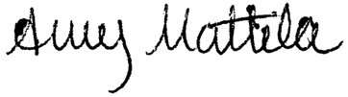
Dr. Amy Mattila, PhD, OTR/L
Assistant Professor
Duquesne University
Health Sciences Building
600 Forbes Avenue
Pittsburgh, PA 15282
4121-396-1648
mattilaa@duq.edu

