A Teacher’s Guide to Emotional Regulation

What is emotional regulation?
The process by which individuals influence which emotions they have, when they have them, and how they experience and express these emotions. It is organized around specific emotions (e.g., sadness, fear, anger) and includes efforts to up- or down-regulate both positive and negative emotions (Compas et al., 2013).

Why is emotional regulation important within the classroom?
Appropriate emotional regulation skills allow students to effectively respond in pressing situations within a classroom environment (AOTA, 2014). Without frequent and effective regulation of emotions, children and their peers may experience lower occupational performance throughout the school day.
Tips for teaching students about their emotions
Use of an emotional scavenger hunt
Students work through a simple scavenger hunt that is focused on identifying objects that elicit specific feelings
For example,
Find an item that helps you calm down when you are upset
Find an item that makes you feel safe when you are scared
Find an item that makes you feel better when you are sick
Find something that might scare someone else
Find an item that you are proud of
Find something that makes you really happy
Find something that makes you excited
Find something that makes you mad or that you do not like
Find something that you use when you feel lonely
FInd something that you enjoy playing with an another person
Find something you use when you are tired

Use of an emotions story
Students focus on a specific object and elaborate on how it makes them feel
For example,
Start off the story with: Once upon a time….
One of the sentences tells what the item looks like
One must tell how it feels when you hold it or touch it
One must describe what it smells like
One must say what kind of sounds it makes
One sentence tells why that item makes you feel _____.

Use of social stories
Students work with a teacher or OT to identify a difficult situation and describe the most appropriate way to respond.
For example,
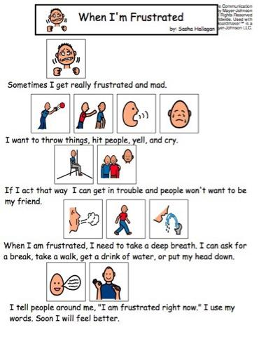

How to help students self-reflect on their emotions
Recognizing how important the problem is
Students can utilize a visual aid to properly identify and work through or identify the severity of a problem
For example,
EMERGENCY | I need to get an adult right away  Someone is in danger, needs to go to the hospital, or there is a fire
GIGANTIC PROBLEM | I will need help from an adult to solve the problem  Bullying, fighting, people being unsafe
BIG PROBLEM | I need to calm down and ask for a break  Not listening, distracting others, yelling while in the classroom
MEDIUM PROBLEM | I need to try to solve my problem first  I need to tell others how I am feeling in a calm voice  I need to take responsibility when I forget things  Not feeling well, being tired, someone is bothering you, you forgot to do something
LITTLE PROBLEM | I need to use my words if I need to take time to solve my problem  I need to use my words to make my needs known  Bathroom break, being hungry or thirsty
NOT A BIG DEAL | I am okay  Losing a game, not being first, losing a turn

Use of a personal checklist
Students can use a self-monitoring behaviors checklist to increase regulation when they feel emotionally imbalanced
For example,
Self Monitoring Behaviors Checklist
Did I listen?
Did I pause and reflect before I acted?
Did I use patience during this task?
Did I use kind words?
Did I lie?
Did I get frustrated?
Did I yell, cry or argue?

Effective and appropriate coping skills for children
Redirecting children to understand their emotions and effectively cope with what they are feeling may reduce problem behaviors in the classroom, while increasing self-management skills
For example,
- Squeeze hands together
- Ask for a break
- Breathe in for 4 seconds and out for 6 seconds
- Take a drink
- Carry books
- Count to 10 in your head
- Tell an adult your emotions
- Calm your body
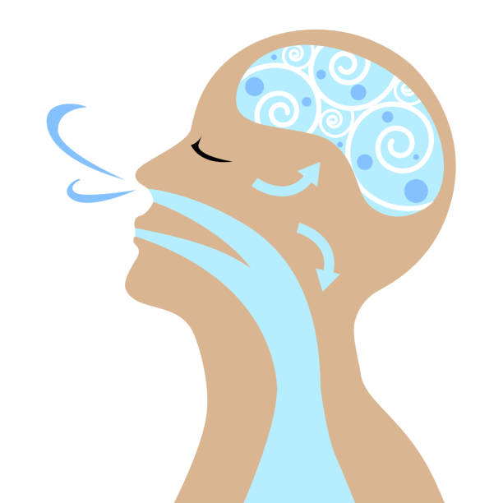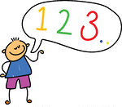

Useful classroom strategies to implement
Utilizing a “zone of regulation”
A visual aid can allow children to identify their emotions, while offering strategies to problem solve and manage these feelings
For example,
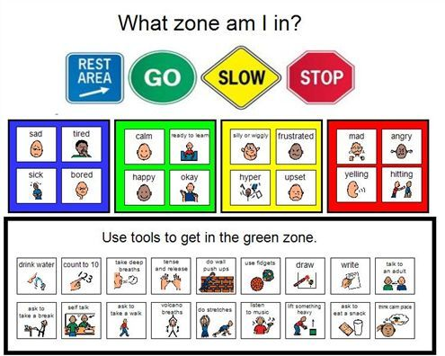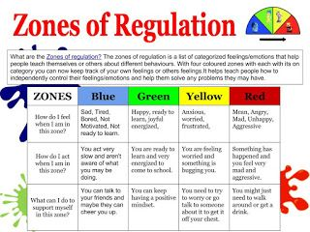

Create a “word wall”
Displaying pictures of emotions with appropriate feelings words can allow students to effectively communicate how they are feeling during a difficult situation
For example,

Include journaling during the school day
Providing children with a journal to keep in the classroom offers space for expression about how they are feeling. This outlet allows for a comfortable and private way to process daily emotions and ask for specific changes in the classroom
For example,
- Free-write about their day
- Use prompts, such as “How I felt today” or “What I need in the classroom”
- Journaling about a time where they felt a specific way

References
American Occupational Therapy Association [AOTA]. Occupational Therapy Practice Framework: Domain and Process (3rd Edition). American Journal of Occupational Therapy 2017;68(Supplement_1):S1-S48. doi: 10.5014/ajot.2014.682006.
Compas, B. E., Jaser, S. S., Dunbar, J. P., Watson, K. H., Bettis, A. H., Gruhn, M. A., & Williams, E. K. (2013). Coping and emotion regulation from childhood to early adulthood: Points of convergence and divergence. Australian Journal of Psychology, 66(2), 71-81. doi:10.1111/ajpy.12043

